Question 1
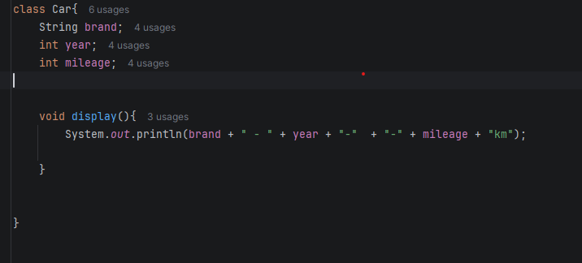

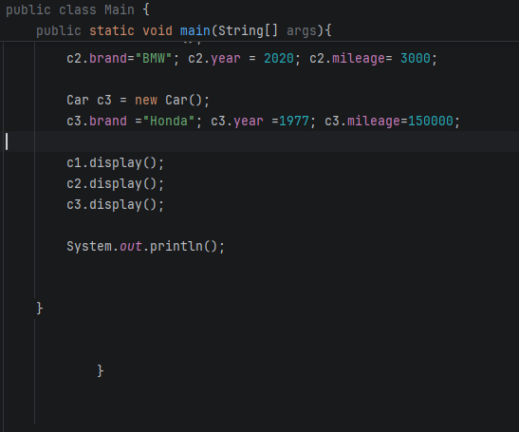
Output
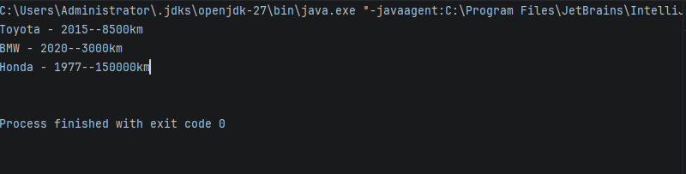

Question 2
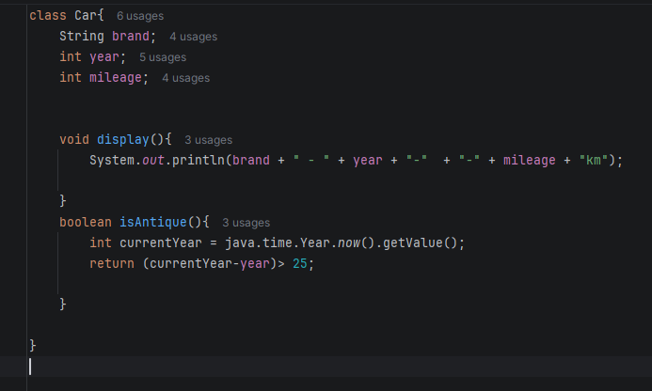

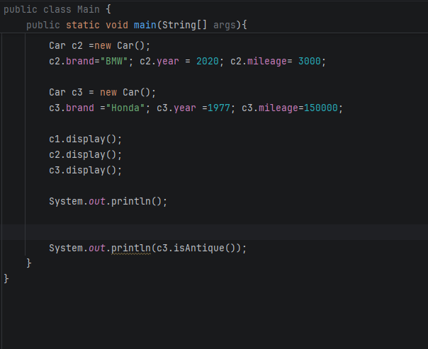
Output

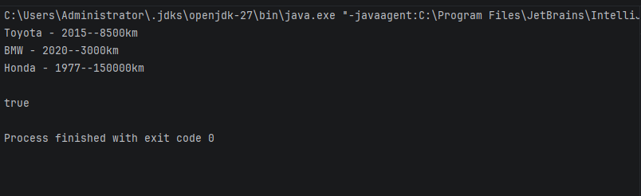
Question 3
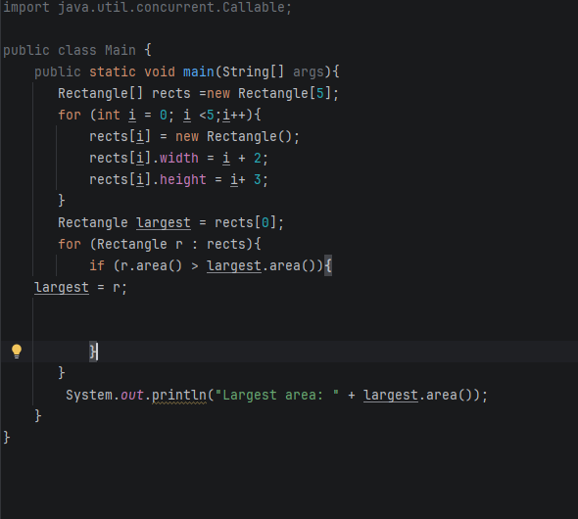
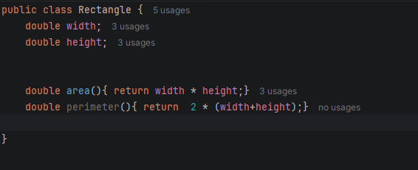

Output
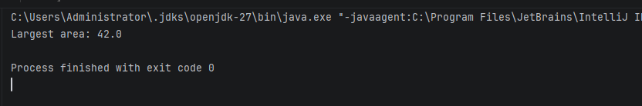
Question 4
public class Rectangle {
double width;
double height;
double area(){ return width * height;}
double perimeter(){ return 2 * (width+height);}
public static void main(String[] args){
Rectangle[] rects =new Rectangle[5];
for (int i = 0; i <5;i++){
rects[i] = new Rectangle();
rects[i].width = i + 2;
rects[i].height = i+ 3;
}
Rectangle largest = rects[0];
for (Rectangle r : rects){
if (r.area() > largest.area()){
largest = r;
}
}
System.out.println("Largest area: " + largest.area());
Rectangle r1 = new Rectangle();
r1.width = 10;
r1.height = 5;
Rectangle r2 = r1;
r2.width = 99;
System.out.println(r1.width);
}
}

Output
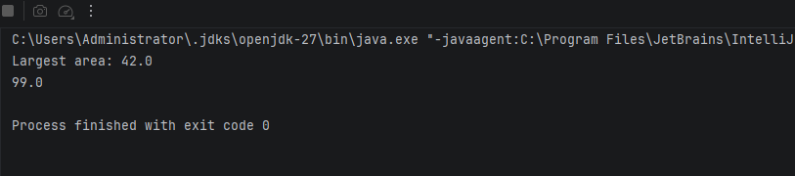
Lab record
In Java, r1and r2 are not objects, they are references (pointers) to an object in memory.r2 =r1 copies the reference, not the object. Now both to the SAME object in the heap. So changing r2.width also changes r1.width.

Question 5
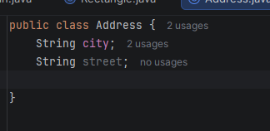
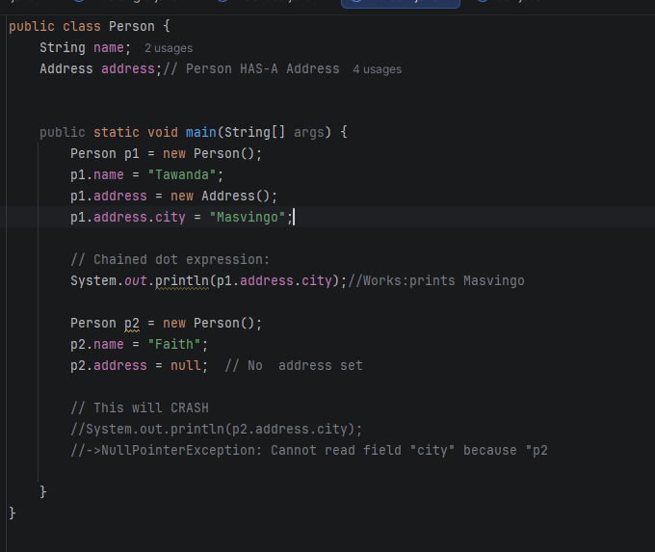

Output
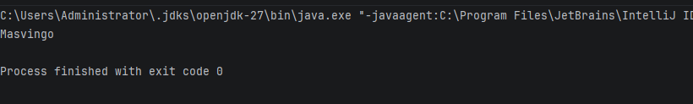

Lab 2
Question 1
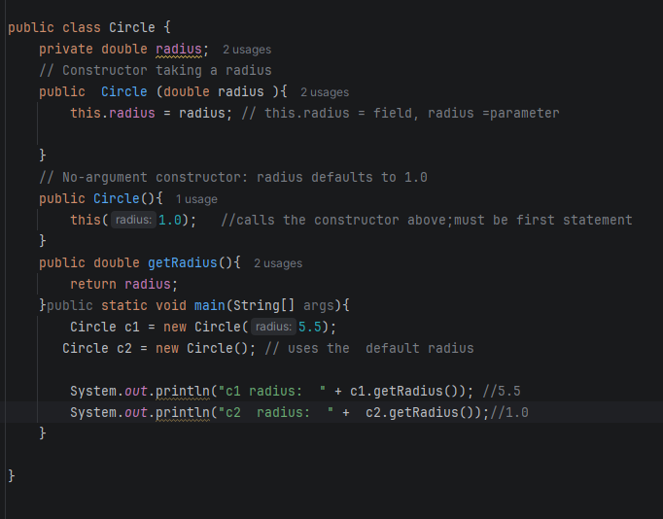

Output
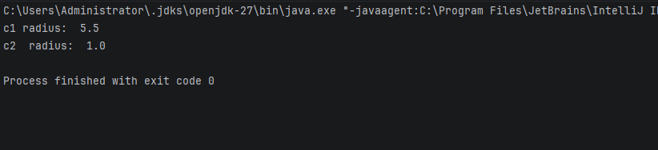

Question 2
import java.util.concurrent.Callable;
public class Circle {
private double radius;
// Constructor taking a radius
private static int count =0;
//
public Circle (double radius ){
this.radius = radius; // this.radius = field, radius =parameter
count ++;
}
// No-argument constructor: radius defaults to 1.0
public Circle(){
this(1.0); //calls the constructor above;must be first statement
}
//Static getter: can be called without creating an object
public static int getCount(){
return count;
}
public double getRadius(){
return radius;
}public static void main(String[] args){
Circle c1 = new Circle(5.5);
Circle c2 = new Circle();
Circle c3 = new Circle(2.0);
System.out.println("c1 radius: " + c1.getRadius()); //5.5
System.out.println("c2 radius: " + c2.getRadius());//1.0
System.out.println("c3 radius: " + c3.getRadius());//2.0
//Called on the class itself, not an object
System.out.println("Circles created: " + Circle.getCount()); //3
}
}
Output
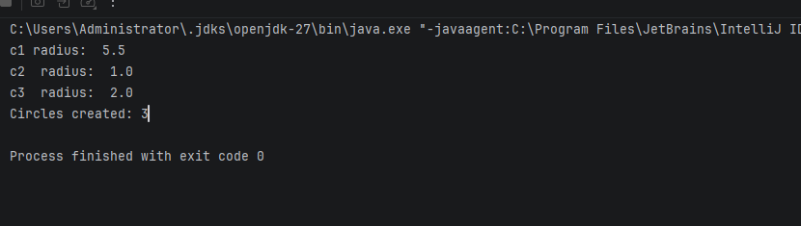

Question 3
public class Employee {
// static: shared by all employees, holds the NEXT id to hand out
private static int nextId=1;
private final int employeeId; // final: assigned once, never changed
private String name;
private double salary;
private String department;
// Main constructor: the other constructors end up calling this one
public Employee(String name,double salary,String department){
this.employeeId =nextId++; // use the current id, then increment
this.name=name;
this.salary=salary;
this.department=department;
}
//Overloaded constructor 2: default department
public Employee(String name, double salary){
this(name,salary,"General");// must be the first statement
}
//Overloaded constructor 3:name only ,default salary
public Employee(String name){
this(name,0.0);
}
// Copy constructor: independent object with the same values.
// It gets its own new id so ids stay unique.
public Employee(Employee other ){
this(other.name, other.salary, other.department);
}
@Override
public String toString() {
return "Employee{id=" + employeeId + ", name=" + name + ", salary=" + salary + ", dept=" + department + "}";
}
public static void main(String[] args){
Employee e1 = new Employee("Faith", 50000, "IT") ;
Employee e2 = new Employee("Tawanda" , 6000);
Employee e3 = new Employee("Meena ");
Employee e4= new Employee(e1); // copy of e1, different id
System.out.println(e1);
System.out.println(e2);
System.out.println(e3);
System.out.println(e4);
System.out.println("e1 == e4" + (e1==e4)); // false: separate objects
}
}

Output
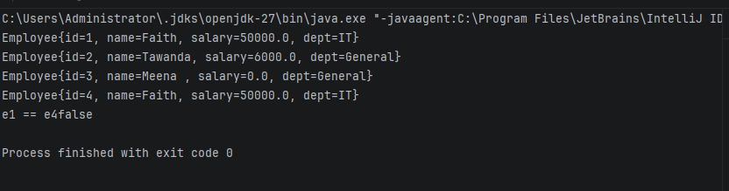
Question 4
public class InitOrder {
// Field initializer: runs as part of instance initialisation, in written order
int value= log("instance field ");
static {
System.out.println("static block 1");
}
{
System.out.println("instance block 1 ");
}
static {
System.out.println("static block 2");
}
{
System.out.println("instance block 2");
}
public InitOrder(){
System.out.println("constructor"); // runs bAFTER the instance parts
}
static int log(String message){
System.out.println(message);
return 0;
}
public static void main(String[] args){
System.out.println("--- first object ---");
new InitOrder();
System.out.println("--- second object ---");
new InitOrder();
}
}

Output
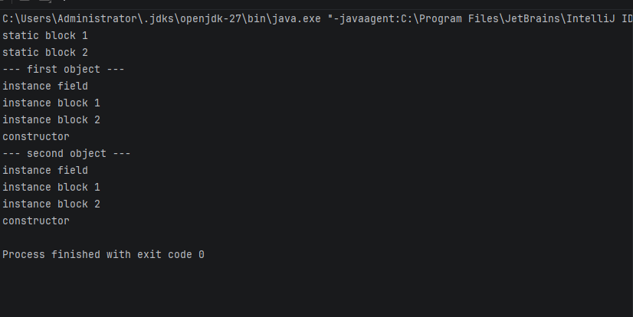

Ouestion5
public class Temperature {
private final double celsius; // stored internally in Celsius
// Private constructor: outside code cannot call "new Temperature(...)"
private Temperature(double celsius){
this.celsius=celsius;
}
// Static factory method: the name says what the number means
public static Temperature fromCelsius(double c ){
return new Temperature(c);
}
//Static factory method:converts Fahrenheit to Celsius first
public static Temperature fromFahrenheit(double f){
return new Temperature((f-32) * 5/9);
}
public double toFahrenheit(){
return celsius* 9/5 + 32;
}
@Override
public String toString(){
return celsius+ " C / " + toFahrenheit() + "F";
}
public static void main(String[] args){
Temperature t1 = Temperature.fromCelsius(100);
Temperature t2=Temperature.fromFahrenheit(32);
System.out.println(t1);// 100.0 C / 212.0 F
System.out.println(t2);// 0.0 C / 32.0 F
}
}

Output
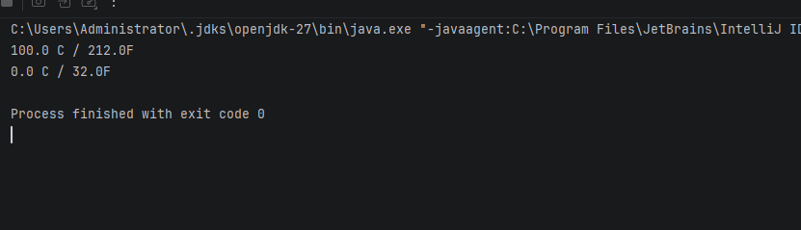
Why static factories can be clearer than overloaded
They are more flexible: A factory method can convert or validate the value before creating the object. A constructor can only build a new one.
Lab 3
Question 1
public class Student {
//private:outside code cannot touch these directly
private String name;
private int marks;
// The constructor goes through the setter, so the same validation applies
public Student(String name, int marks){
this.name=name;
setMarks(marks);
}
public String getName(){
return name;
}
public int getMarks() {
return marks;
}
// Setter with validation: reject marks outside 0 to 100
public void setMarks(int marks){
if (marks <0 || marks >100){
throw new IllegalArgumentException("Marks must be between 0 to 100, got:" + marks );
}
this.marks=marks;
}
public static void main(String[] args){
Student s= new Student("Faith" ,75);
System.out.println(s.getName() + " has " + s.getMarks()+ " marks"); // Faith has 75 marks
s.setMarks(90); // valid, accepted
System.out.println("Updated marks: " + s.getMarks());
try {
s.setMarks(150);// invalid, rejected
}catch (IllegalArgumentException e){
System.out.println("Rejected: " + e.getMessage());
}
System.out.println("Marks are still: " + s.getMarks());
}
}

Output
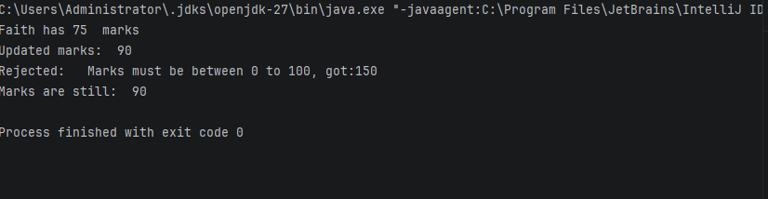
Question 2
public class Student {
//private:outside code cannot touch these directly
private String name;
private int marks;
// The constructor goes through the setter, so the same validation applies
public Student(String name, int marks){
this.name=name;
setMarks(marks);
}
public String getName(){
return name;
}
public int getMarks() {
return marks;
}
//Return the grade calculated from the marks.
//There is no grade field: it is worked out each time, so it can never be out of date.
public char getGrade(){
if (marks >= 80 ){
return 'A';
}else if (marks >= 70){
return 'B';
}else if (marks >= 50){
return 'C';
}else{
return'F';
}
}
// Setter with validation: reject marks outside 0 to 100
public void setMarks(int marks){
if (marks <0 || marks >100){
throw new IllegalArgumentException("Marks must be between 0 to 100, got:" + marks );
}
this.marks=marks;
}
public static void main(String[] args){
Student s= new Student("Faith" ,75);
System.out.println(s.getName() + " has " + s.getMarks()+ " marks"); // Faith has 75 marks
s.setMarks(90); // valid, accepted
System.out.println("Updated marks: " + s.getMarks());
System.out.println("Grade: " + s.getGrade()); // marks are 90 , so A
s.setMarks(65);
System.out.println("Grade: " + s.getGrade()); // C
s.setMarks(30);
System.out.println("Grade: " + s.getGrade()); //F
try {
s.setMarks(150);// invalid, rejected
}catch (IllegalArgumentException e){
System.out.println("Rejected: " + e.getMessage());
}
System.out.println("Marks are still: " + s.getMarks());
}
}

Output
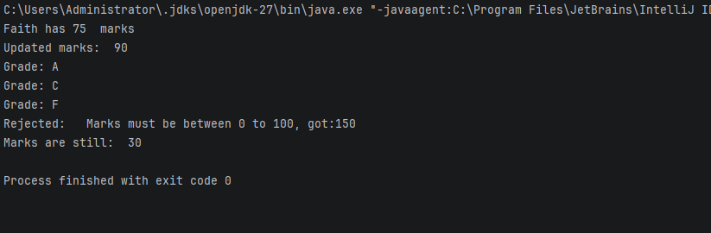
Question 3
import java.util.ArrayList;
import java.util.Collections;
import java.util.List;
public class BankAccount {
private double balance;
private List<String> history = new ArrayList<>();
public void deposit(double amount){
balance += amount;
history.add("Deposited " + amount);
}
// Unmodifiable copy: callers can read it but not change it
public List<String>getHistory(){
return Collections.unmodifiableList(new ArrayList<>(history));
}
public static void main(String[] args){
BankAccount acc = new BankAccount();
acc.deposit(500);
System.out.println(acc.getHistory()); // [Deposited 500.0]
try{
acc.getHistory().add("Hacked"); // blocked
}catch (UnsupportedOperationException e ){
System.out.println("History cannot be modified");
}
}
}

Output
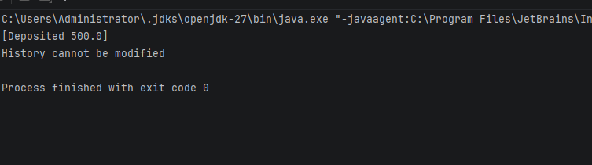
Question 4
//final class: nobody can extend it and override methods to change its behaviour
public class ImmutablePerson {
//private final fields: assigned once in the constructor, never changed
private final String name;
private final int age;
public ImmutablePerson(String name, int age){
this.name =name;
this.age=age;
}
// Getters only, no setters
public String getName(){
return name;
}
public int getAge() {
return age;
}
public static void main(String[] args){
ImmutablePerson p= new ImmutablePerson("Faith" , 20);
System.out.println(p.getName() + "," + p.getAge());
}
}

Output
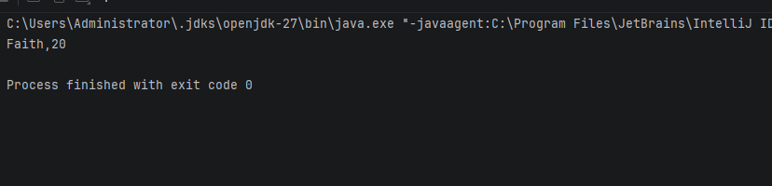
Explanation
final class: it cant be subclassed, so no child can address setters or override methods to make the objects changeable.
private fields : outside code cant read or change them directly.
final fields: each can be assigned only once, in the constructor, so the values cant change after the object is created.
No setters: there is no method that can change the state, so the object stays the same for its whole life.
Question 5
public class TemperatureK {
// Internal unit is kelvin. It is private, so callers never see it.
private final double kelvin;
public TemperatureK(double kelvin){
//Reject values below absolute zero (0 k)
if (kelvin<0){
throw new IllegalArgumentException("Below absolute zero:" + kelvin);
}
this.kelvin=kelvin;
}
public double getCelsius(){
return kelvin-273.15;
}
public double getFahrenheit(){
return getCelsius()* 9/ 5 + 32;
}
public static void main(String[] args){
TemperatureK t = new TemperatureK(300);
System.out.println(t.getCelsius()); // 26.850000000000023
System.out.println(t.getFahrenheit()); // 80.330000000004
try{
new TemperatureK(-5); //invalid,rejected
}catch (IllegalArgumentException e) {
System.out.println("Rejected:" + e.getMessage());
}
}
}

Output
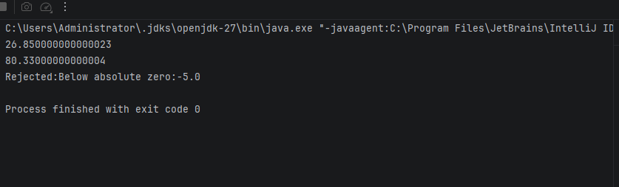
Lab4
Question1
public class Person4 {
String name;
int age;
Person4(String name, int age){
this.name=name;
this.age=age;
}
// Inherited by Student, so it is written only once
void display(){
System.out.println("Name:" + name + " , Age: " + age);
}
}
//extends = Students IS-A Person
class Student4 extends Person4{
String course;
Student4(String name, int age, String course){
super(name,age); // calls the Person constructor; must be the first statement
this.course=course;
}
}
class Person4Demo{
public static void main(String[] args){
Person4 p = new Person4("Faith" , 40);
Student4 s = new Student4("Rudo" , 20, "OOP");
p.display(); // Name:Faith, Age :40
s.display(); // Name:Rudo, Age: 20(inherited method)
System.out.println("Course: " + s.course); // Course:OOP
}
}

Output
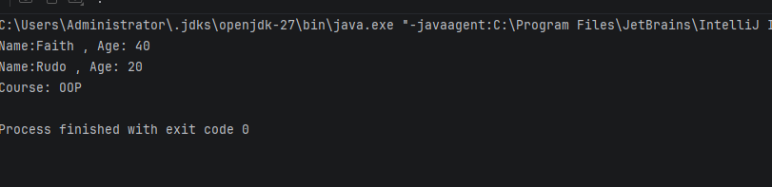
Question2
public class Person4 {
String name;
int age;
Person4(String name, int age){
this.name=name;
this.age=age;
}
// Inherited by Student, so it is written only once
void display(){
System.out.println("Name:" + name + " , Age: " + age);
}
}
//extends = Students IS-A Person
class Student4 extends Person4{
String course;
Student4(String name, int age, String course){
super(name,age); // calls the Person constructor; must be the first statement
this.course=course;
}
}
class Teacher4 extends Person4{
String subject;
Teacher4(String name, int age , String subject){
super(name,age); // refuses the Person4 constructor
this.subject=subject;
}
}
class Person4Demo{
public static void main(String[] args){
Teacher4 t = new Teacher4("Faith" , 40, "JAVA");
Student4 s = new Student4("Rudo" , 20, "OOP");
//Both call the SAME display() method which is written once in Person4
t.display(); // Name:Faith, Age :40
s.display(); // Name:Rudo, Age: 20(inherited method)
System.out.println("Course: " + s.course); // Course:OOP
System.out.println("Subject: "+ t.subject );// Subject:JAVA
}
}

Output
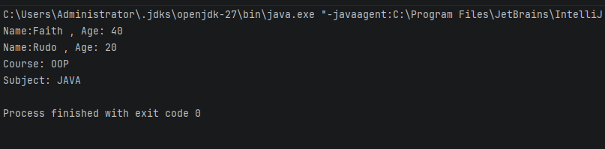
Question 3
public class Vehicle4 {
Vehicle4(){
System.out.println("1. Vehicle constructor");
}
}
class Car4 extends Vehicle4{
Car4(){
// Java inserts super() here automatically, so Vehicle4 runs first
System.out.println("3. ElectricCar constructor");
}
}
class ElectricCar4 extends Car4{
ElectricCar4(){
// Java inserts super() here automatically, so Vehicle4 runs next
System.out.println("3. ElectricCar constructor");
}
}
class ConstructorOrder{
public static void main(String[] args){
new ElectricCar4();
}
}

Output
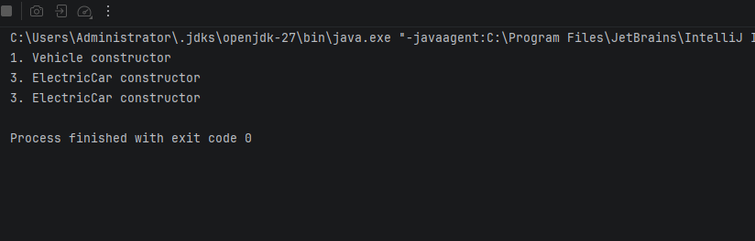
Question4
public class Animal4 {
String name;
// Only a constructor with a parameter: Java does NOT create a default one
Animal4(String name){
this.name=name;
}
}
// FAILS TO COMPILE:
// class Dod4 extends Animal4{
// Dod4() // Java inserts super() automatically, nut Animal4 has no
//} //no-argument constructor -> compile error
// FIX: call the Animal4 constructor yourself with super(name)
class Dog4 extends Animal4{
Dog4(String name ){
super(name); // must be the first statement
}
}
class AnimalDemo{
public static void main(String[] args){
Dog4 d = new Dog4("Rex");
System.out.println("Dog name: " + d.name ); // Dog name: Rex
}
}
Output
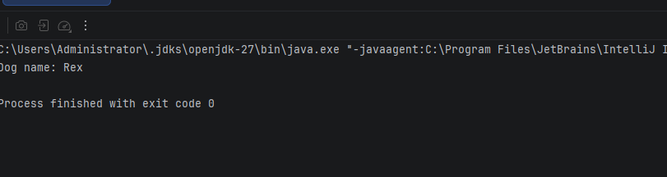
Question5
import java.util.ArrayList;
// BEFORE (inheritance): class Stack extends ArrayList<String> {...}
// It wrongly exposes add(index , x ), remove(index), get(i), set(...), clear()
//AFTER (composition): a Stack HAS-A list
public class Stack {
private final ArrayList<String> items = new ArrayList<>(); // hidden
public void push(String item) {items.add(item);}
public String pop() {return items.remove(items.size() -1);}
public static void main(String[] args){
Stack s = new Stack();
s.push("A");
s.push("B");
System.out.println(s.pop()); //B
System.out.println(s.pop()); //A
// s.add(0, "X"; // compile error: Stack has no add() method
}
}

Qutput
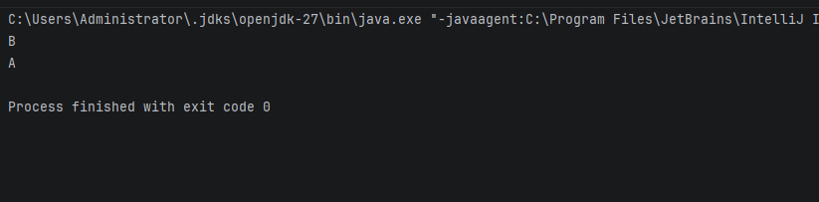
Lab5
Question 1
public class PrintDemo {
//Overloading: same method name, different parameter types(same class)
static void print (int x) {
System.out.println("int:" + x );
}
static void print(double x) {
System.out.println("double: " + x);
}
static void print(String x){
System.out.println("String: " + x);
}
static void print(int[] x) {
System.out.println("int[]: " + java.util.Arrays.toString(x));
}
public static void main(String[] args){
print(5); // int version
print(3.14); // double version
print("Hello"); //String version
print(new int[]{1,2,3}); // int [] version
}
}

Qutput
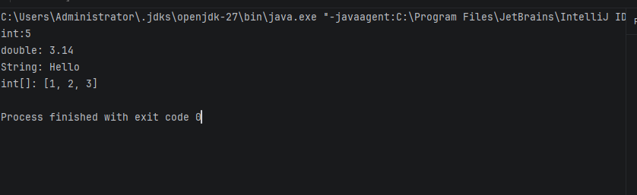
Question2
public class Animal {
void sound() {
System.out.println("Some animal sound");
}
}
class Cat extends Animal {
@Override
void sound() {
System.out.println("Meow");
}
}
class Cow extends Animal {
@Override
void sound() {
System.out.println("Moo");
}
}
class Duck extends Animal {
@Override
void sound() {
System.out.println("Quack");
}
}
class AnimalTest {
public static void main(String[] args){
// Animal[] holds all three subclasses (upcasting)
Animal[] animals= {new Cat(), new Cow(), new Duck()};
// Loop through the array and call sound() on each
for(Animal a : animals){
a.sound();
}
}
}
Qutput
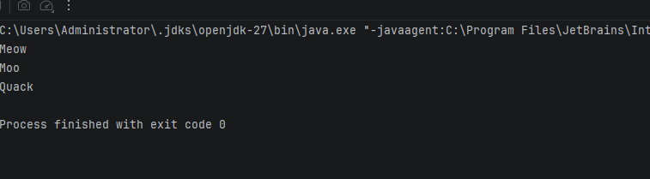
Question 3
public class Employee5 {
double pay= 3000;
double calculatePay(){return pay;}
}
class Manager extends Employee5{
@Override
double calculatePay(){ return pay+ 1500;}
}
class Intern extends Employee5{ // the new class
@Override
double calculatePay(){return 800;}
}
class Payroll {
public static void main(String[] args) {
Employee5[] staff = {new Employee5(), new Manager(), new Intern()};
double total = 0;
for (Employee5 e : staff) { // loop never mentions Intern
total += e.calculatePay();
}
System.out.println("Total payroll: " + total); // 9300.0
}
}

Output
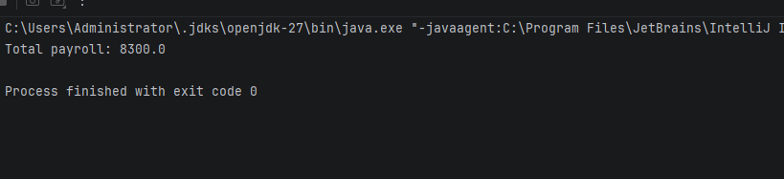
Question 4
public class Base {
String name = "Base field";
void show() {
System.out.println("Base method");
}
}
class Derived extends Base {
String name = "Derived field"; // hides the field (does not override it)
@Override
void show() {
System.out.println("Derived method");
}
}
class FieldVsMethod{
public static void main(String[] args){
Base b = new Derived(); // superclass reference,subclass object
b.show(); // method: Derived method
System.out.println(b.name); // field: Base field
System.out.println(((Derived)b).name); // cast: Derived field
}
}
Qutput
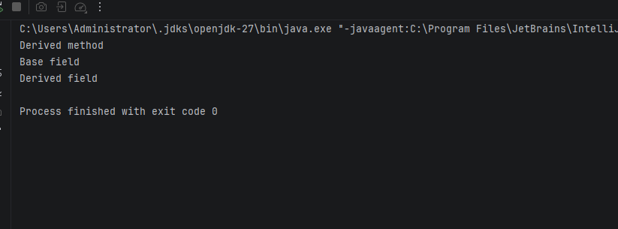
Question5
public class Payment {
void process() {
System.out.println("Generic");
}
}
class CardPayment extends Payment {
@Override
void process() {
System.out.println("Card processed");
}
}
class MobileMoneyPayment extends Payment {
@Override
void process() {
System.out.println("Mobile money processed");
}
}
class PaymentProcessor {
// BEFORE: instanceof pattern matching
static void payOld(Payment p) {
if (p instanceof CardPayment c) System.out.println(" Card handled");
else if (p instanceof MobileMoneyPayment m) System.out.println("Mobile money handled");
}
// AFTER: refactored to use polymorphic process()
static void pay(Payment p) {
p.process();
}
public static void main(String[] args) {
Payment[] list = {new CardPayment(), new MobileMoneyPayment()};
for (Payment p : list) payOld(p);
for (Payment p : list) pay(p);
}
}

Qutput
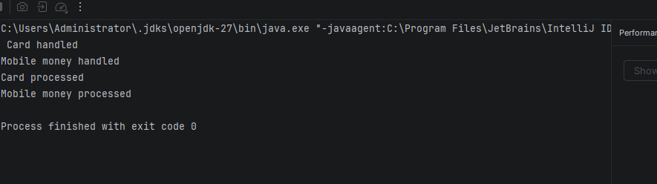
Lab6
Question 1
// Abstract class: partly built, cannot be instantiated with new
abstract class Shape {
abstract double area(); // abstract = no body, subclasses must implement
abstract double perimeter();
}
//Circle IS-A Shape
class Circle6 extends Shape{
double r;
Circle6(double r) {this.r =r ;}
@Override double area(){return 2* Math.PI* r * r ;} // pi * r^2
@Override double perimeter(){return 2* Math.PI*r;} // 2* pi*r
}
class Rectangle6 extends Shape{
double w, h;
Rectangle6(double w, double h){this.w = w; this.h =h;}
@Override double area(){return w* h;} // width* height
@Override double perimeter(){return 2* (w+h);}// 2*(w+ h)
}
class Square extends Shape{
double s;
Square(double s ){this.s=s;}
@Override double area(){return s* s;} // side squared
@Override double perimeter(){return 4*s;} // 4* side
}
class ShapeDemo{
public static void main(String[] args){
// new Shape(); // compile error: abstract class cannot be instantiated
// Upcasting: one Shape array holds all three subclasses
Shape[] shapes = {new Circle6(2), new Rectangle6(3,4), new Square(5)};
// Each call runs the real object's own are() and perimeter()
for (Shape sh : shapes)
System.out.println(sh.area() + "" + sh.perimeter());
}
}

Output
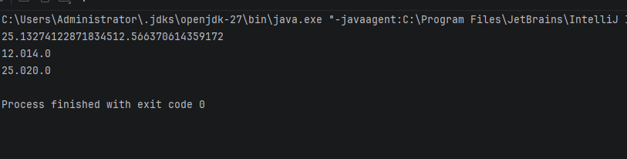
Question 2
// Interface: a contract of capabilities. Methods are public by default.
interface Flyable {
void fly();
}
// Bird and Aeroplane share no superclass, but both can fly
class Bird implements Flyable {
@Override
public void fly() { System.out.println("Bird flaps its wings"); } // must be public
}
class Aeroplane implements Flyable {
@Override
public void fly() { System.out.println("Aeroplane uses its engines"); }
}
class FlyDemo {
public static void main(String[] args) {
// Program to the interface: the array type is Flyable, not Bird or Aeroplane
Flyable[] things = { new Bird(), new Aeroplane() };
for (Flyable f : things)
f.fly(); // each object runs its own fly()
}
}
Qutput
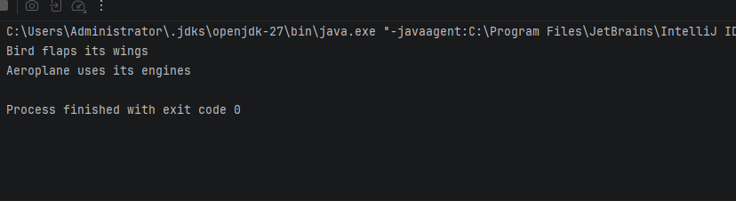
Question 3
// Abstract class: shared state and concrete methods, plus abstract methods
abstract class Account6 {
protected double balance;
// Concrete method: written once, inherited by all accounts
void deposit(double amount) { balance += amount; }
// Abstract method: each account type decides its own fee
abstract double monthlyFee();
}
class SavingsAccount6 extends Account6 {
@Override double monthlyFee() { return 5; }
}
class CurrentAccount6 extends Account6 {
@Override double monthlyFee() { return 20; }
}
class AccountDemo {
public static void main(String[] args) {
Account6[] accounts = { new SavingsAccount6(), new CurrentAccount6() };
for (Account6 a : accounts) {
a.deposit(1000); // inherited concrete method
System.out.println("Balance: " + a.balance + ", fee: " + a.monthlyFee());
}
}
}

Output
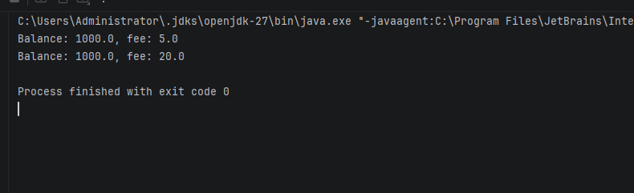
Question 4
import java.util.Arrays;
import java.util.Comparator;
class Student6 implements Comparable<Student6> {
String name;
int marks;
Student6(String name, int marks) { this.name = name; this.marks = marks; }
// Natural ordering: by name (A to Z)
@Override
public int compareTo(Student6 other) {
return this.name.compareTo(other.name);
}
@Override
public String toString() { return name + "(" + marks + ")"; }
}
// Comparator: a separate, extra ordering by marks (highest first)
class MarksComparator implements Comparator<Student6> {
@Override
public int compare(Student6 a, Student6 b) {
return Integer.compare(b.marks, a.marks);
}
}
class SortDemo {
public static void main(String[] args) {
Student6[] students = {
new Student6("Rudo", 70), new Student6("Asha", 95), new Student6("Faith", 82)
};
Arrays.sort(students); // uses compareTo (by name)
System.out.println("By name: " + Arrays.toString(students));
Arrays.sort(students, new MarksComparator()); // uses the Comparator
System.out.println("By marks: " + Arrays.toString(students));
}
}
Output
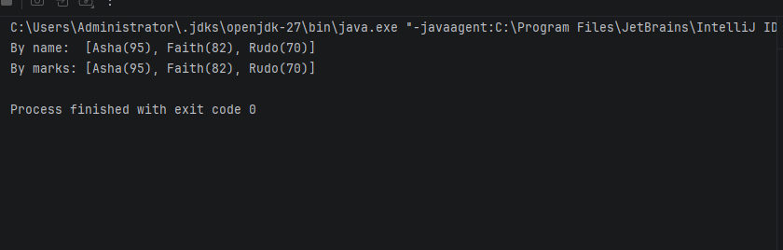
Question5
interface A {
default void hello() { System.out.println("Hello from A"); }
}
interface B {
default void hello() { System.out.println("Hello from B"); }
}
// C inherits two default hello() methods, so the compiler forces it to resolve the conflict
class C implements A, B {
@Override
public void hello() {
A.super.hello(); // explicitly call A's version
B.super.hello(); // explicitly call B's version
}
}
class DiamondDemo {
public static void main(String[] args) {
new C().hello();
}
}

Qutput
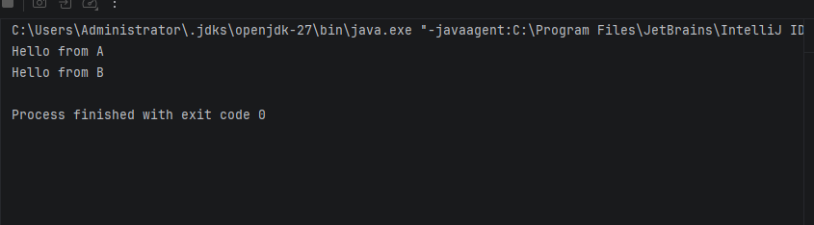
Lab 7
Question1
import java.util.InputMismatchException;
import java.util.Scanner;
class DivideDemo {
public static void main(String[] args) {
Scanner sc = new Scanner(System.in);
try {
System.out.print("Enter first integer: ");
int a = sc.nextInt(); // throws InputMismatchException if not a number
System.out.print("Enter second integer: ");
int b = sc.nextInt();
System.out.println("Result: " + (a / b)); // throws ArithmeticException if b is 0
} catch (InputMismatchException e) {
System.out.println("Error: please enter whole numbers only.");
} catch (ArithmeticException e) {
System.out.println("Error: cannot divide by zero.");
} finally {
sc.close(); // always runs, whether or not an exception happened
}
}
}

Output
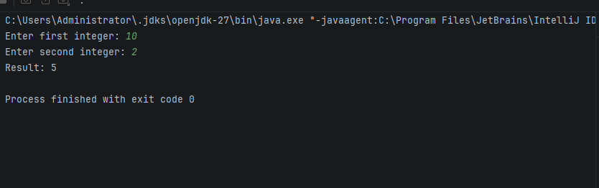
Question2
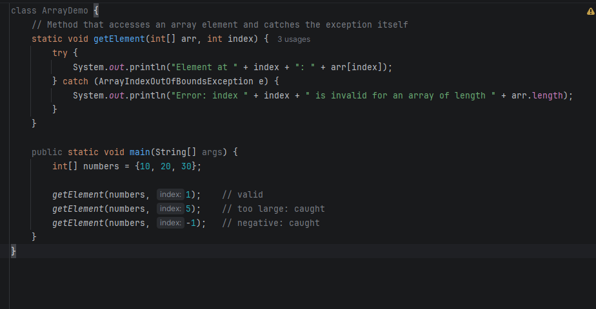

Qutput
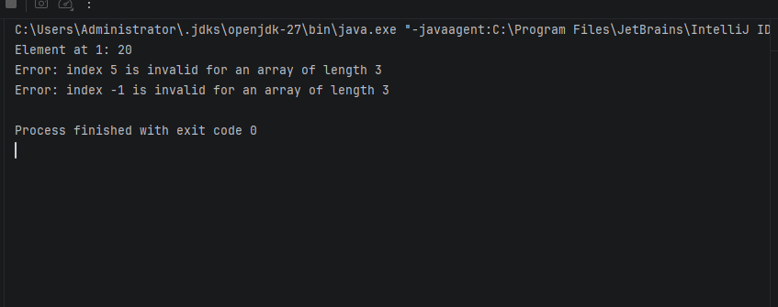

Question 3
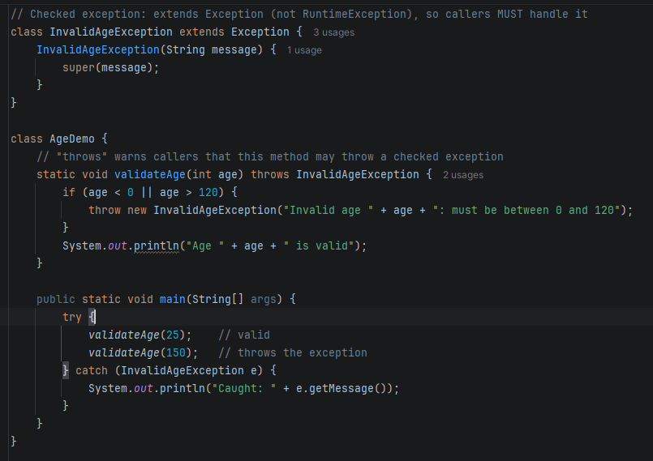

Output
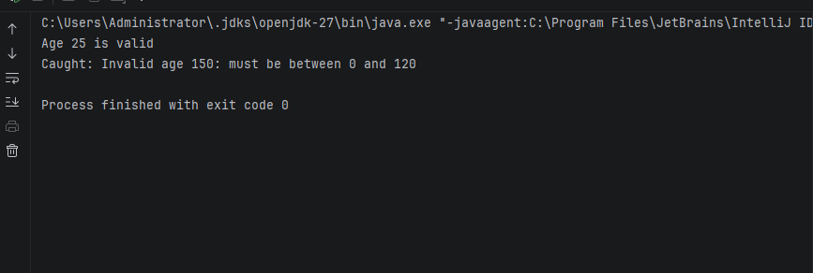
Question4
import java.util.ArrayList;
import java.util.Collections;
import java.util.List;
// NEW: checked exception thrown when a withdrawal is too large
class InsufficientFundsException extends Exception {
InsufficientFundsException(String message) {
super(message);
}
}
public class BankAccount {
private double balance;
private List<String> history = new ArrayList<>();
public void deposit(double amount) {
balance += amount;
history.add("Deposited " + amount);
}
// ORIGINAL (Lab 3): returned false when the balance was too low
// public boolean withdraw(double amount) {
// if (amount > balance) {
// return false;
// }
// balance -= amount;
// history.add("Withdrew " + amount);
// return true;
// }
// MODIFIED: now returns void and throws an exception instead of returning false
public void withdraw(double amount) throws InsufficientFundsException {
if (amount > balance) {
throw new InsufficientFundsException(
"Cannot withdraw " + amount + ": balance is only " + balance);
}
balance -= amount;
history.add("Withdrew " + amount);
}
public double getBalance() {
return balance;
}
// Unmodifiable copy: callers can read it but not change it
public List<String> getHistory() {
return Collections.unmodifiableList(new ArrayList<>(history));
}
public static void main(String[] args) {
BankAccount acc = new BankAccount();
acc.deposit(500);
System.out.println(acc.getHistory()); // [Deposited 500.0]
try {
acc.getHistory().add("Hacked"); // blocked
} catch (UnsupportedOperationException e) {
System.out.println("History cannot be modified");
}
// The caller must now handle the exception (try/catch is required)
try {
acc.withdraw(200); // succeeds
System.out.println("Balance: " + acc.getBalance());
acc.withdraw(1000); // throws
} catch (InsufficientFundsException e) {
System.out.println("Caught: " + e.getMessage());
}
System.out.println(acc.getHistory());
}
}

Output
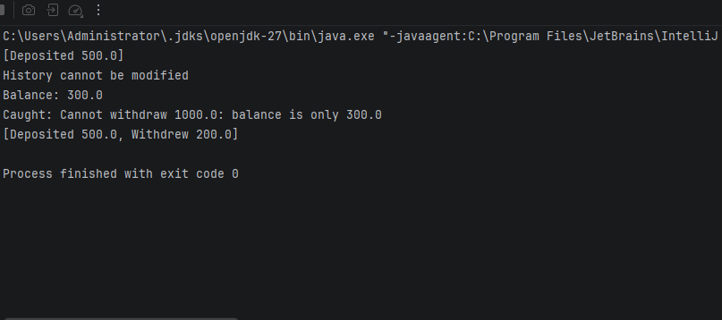

Question5
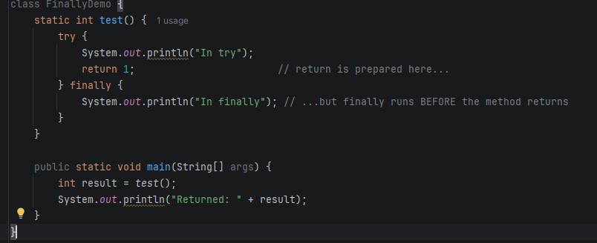

Output
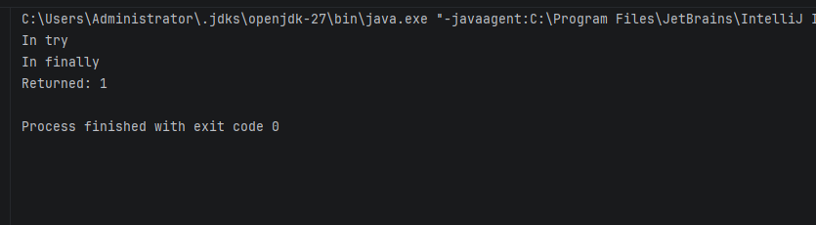

Lab8
Question1
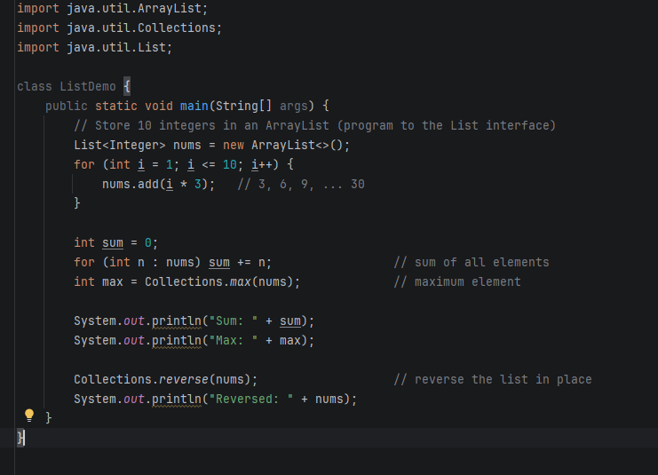
Output
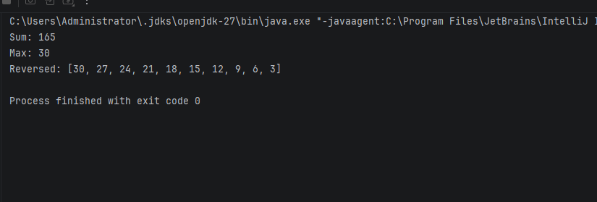
Question2
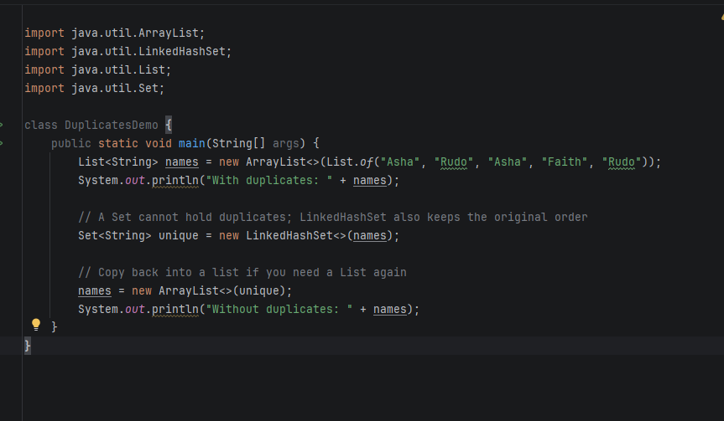
Output
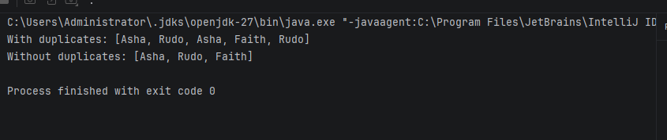
Question3
import java.util.ArrayList;
// Generic class: T is the type supplied by the caller (Stack8<String>, Stack8<Integer>)
class Stack8<T> {
private final ArrayList<T> items = new ArrayList<>(); // backing list, hidden from callers
void push(T item) { items.add(item); } // add on top
T pop() { // remove and return the top
if (items.isEmpty()) throw new RuntimeException("Stack is empty");
return items.remove(items.size() - 1);
}
T peek() { // look at the top without removing
if (items.isEmpty()) throw new RuntimeException("Stack is empty");
return items.get(items.size() - 1);
}
boolean isEmpty() { return items.isEmpty(); }
}
class StackTest {
public static void main(String[] args) {
Stack8<String> s = new Stack8<>(); // a stack of Strings
s.push("A");
s.push("B");
s.push("C");
System.out.println("Peek: " + s.peek()); // C
System.out.println("Pop: " + s.pop()); // C
System.out.println("Pop: " + s.pop()); // B
System.out.println("Empty? " + s.isEmpty()); // false
Stack8<Integer> n = new Stack8<>(); // the same class works for Integers
n.push(10);
System.out.println("Integer pop: " + n.pop()); // 10
}
}

Output
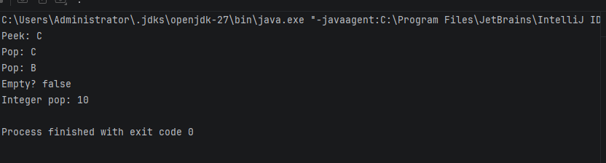

Question4
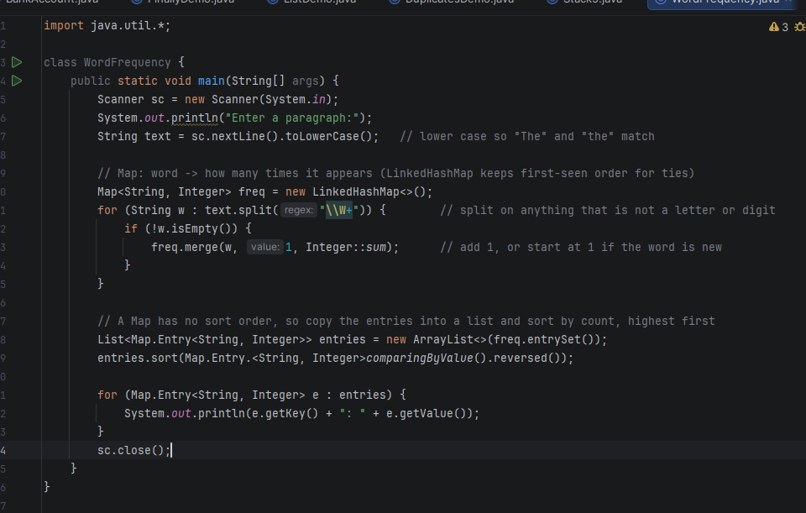

Output
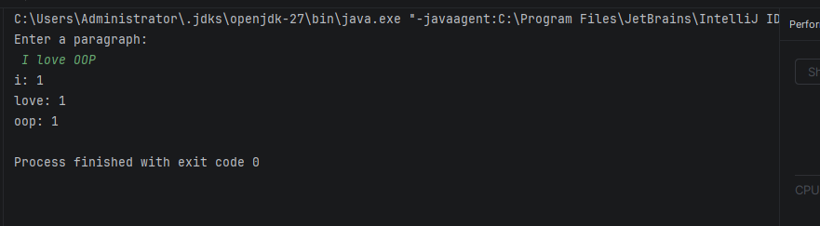
Question5
import java.util.Arrays;
class BubbleDemo {
// Bounded type parameter: T must be Comparable, so compareTo() is guaranteed to exist
static <T extends Comparable<T>> void bubbleSort(T[] arr) {
for (int i = 0; i < arr.length - 1; i++) {
for (int j = 0; j < arr.length - 1 - i; j++) {
if (arr[j].compareTo(arr[j + 1]) > 0) { // out of order, so swap
T temp = arr[j];
arr[j] = arr[j + 1];
arr[j + 1] = temp;
}
}
}
}
public static void main(String[] args) {
Integer[] nums = {5, 2, 9, 1};
bubbleSort(nums);
System.out.println(Arrays.toString(nums)); // [1, 2, 5, 9]
String[] words = {"pear", "apple", "mango"};
bubbleSort(words);
System.out.println(Arrays.toString(words)); // [apple, mango, pear]
// int[] raw = {3, 1, 2};
// bubbleSort(raw); // compile error: int[] is not a T[]
}
}

Output
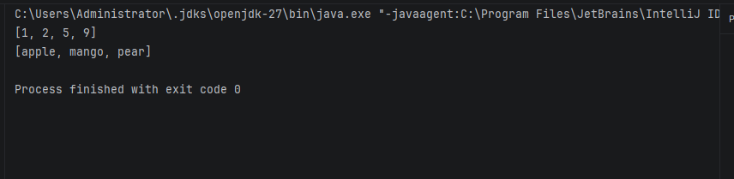

Lab9
Question1
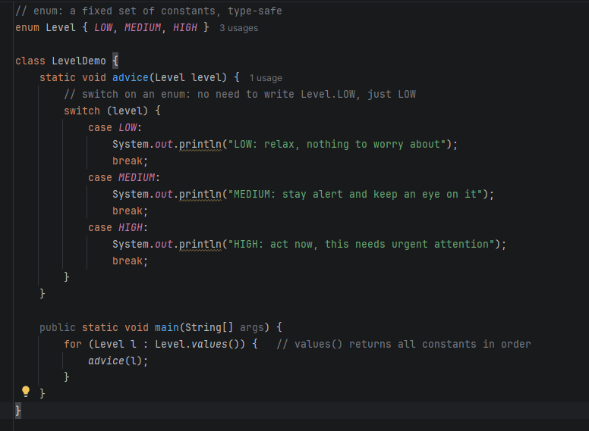
Output
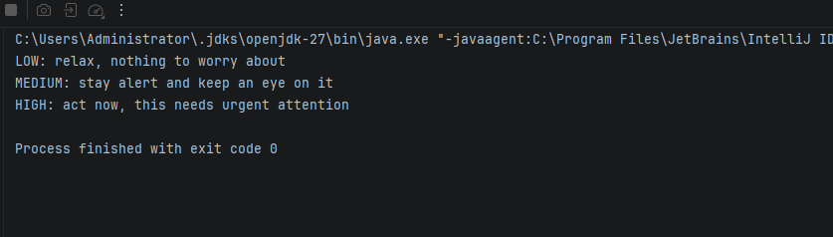
Question2
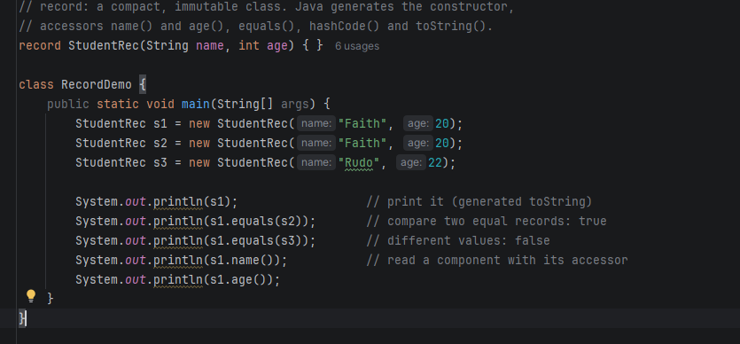
Output
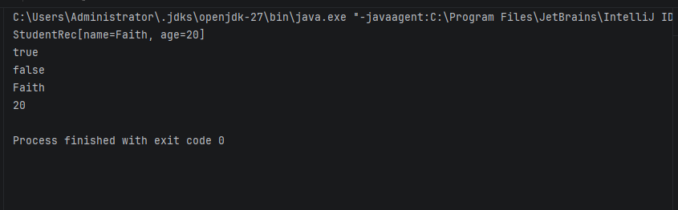

Question3
import java.util.HashSet;
import java.util.Objects;
import java.util.Set;
class Book9 {
String isbn;
String title;
Book9(String isbn, String title) { this.isbn = isbn; this.title = title; }
// equals(Object o), not equals(Book9 b): that would overload instead of override
@Override
public boolean equals(Object o) {
if (this == o) return true;
if (!(o instanceof Book9)) return false;
Book9 other = (Book9) o;
return isbn.equals(other.isbn); // two books are equal if the ISBN matches
}
// Must be consistent with equals: equal objects need equal hash codes
@Override
public int hashCode() { return Objects.hash(isbn); }
@Override
public String toString() { return title + " (" + isbn + ")"; }
}
class BookDemo {
public static void main(String[] args) {
Set<Book9> books = new HashSet<>();
System.out.println(books.add(new Book9("111", "Java Basics"))); // true: added
System.out.println(books.add(new Book9("222", "OOP Concepts"))); // true: added
System.out.println(books.add(new Book9("111", "Java Basics 2"))); // false: same ISBN, rejected
System.out.println("Set size: " + books.size()); // 2
System.out.println(books);
}
}

Output
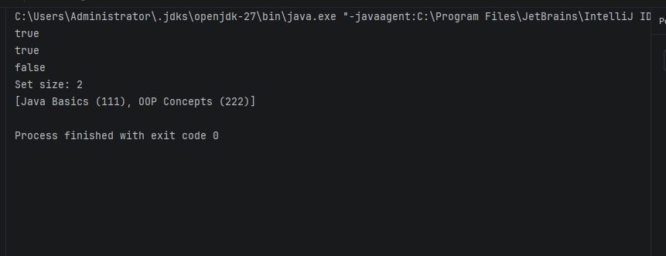
Question4
import java.util.Iterator;
// Iterable<T> is what allows the for-each loop on this class
class MyLinkedList<T> implements Iterable<T> {
// Static nested class: a helper that needs no access to the outer object
private static class Node<T> {
T data;
Node<T> next;
Node(T data) { this.data = data; }
}
private Node<T> head, tail;
void add(T value) { // add at the end
Node<T> n = new Node<>(value);
if (head == null) head = tail = n;
else { tail.next = n; tail = n; }
}
// Inner (non-static) class: it uses the outer object's head field
private class ListIterator implements Iterator<T> {
private Node<T> current = head; // starts at the outer list's head
@Override public boolean hasNext() { return current != null; }
@Override public T next() {
T value = current.data;
current = current.next;
return value;
}
}
@Override
public Iterator<T> iterator() { return new ListIterator(); }
public static void main(String[] args) {
MyLinkedList<String> list = new MyLinkedList<>();
list.add("A");
list.add("B");
list.add("C");
for (String s : list) { // works because of the iterator
System.out.println(s);
}
}
}

Output
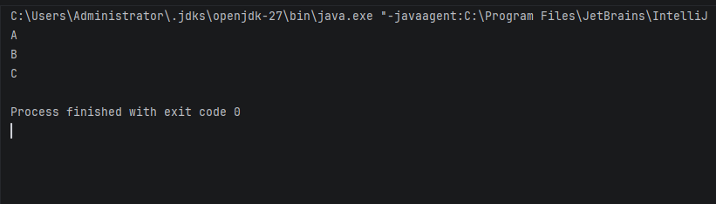
Question5
import java.util.ArrayList;
import java.util.List;
// enum with a field, a constructor and a method
enum Coin {
// Constants are listed from largest to smallest, so the greedy method below works
QUARTER(25), DIME(10), NICKEL(5), PENNY(1);
private final int value; // value in cents
Coin(int value) { this.value = value; } // enum constructors are always private
int getValue() { return value; }
// Returns the fewest coins for the amount (greedy: take the biggest coin that fits)
static List<Coin> fewestCoins(int amount) {
List<Coin> result = new ArrayList<>();
for (Coin c : values()) { // values() gives the constants in declared order
while (amount >= c.value) {
result.add(c);
amount -= c.value;
}
}
return result;
}
}
class CoinDemo {
public static void main(String[] args) {
System.out.println(Coin.fewestCoins(41)); // [QUARTER, DIME, NICKEL, PENNY]
System.out.println(Coin.fewestCoins(99)); // [QUARTER x3, DIME x2, PENNY x4]
}
}

Output
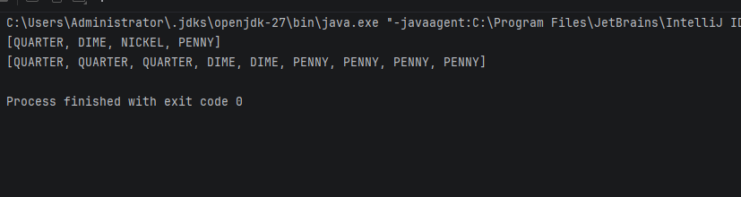
Lab10
Question1
import java.io.IOException;
import java.nio.file.Files;
import java.nio.file.Path;
import java.util.ArrayList;
import java.util.List;
import java.util.Scanner;
class FileDemo {
public static void main(String[] args) {
Scanner sc = new Scanner(System.in);
List<String> lines = new ArrayList<>();
// Read five lines typed by the user
for (int i = 1; i <= 5; i++) {
System.out.print("Line " + i + ": ");
lines.add(sc.nextLine());
}
Path file = Path.of("notes.txt"); // relative path: created in the working directory
try {
Files.write(file, lines); // save all five lines to the file
List<String> saved = Files.readAllLines(file); // read them back
System.out.println("--- Read back from " + file + " ---");
for (String s : saved) {
System.out.println(s);
}
} catch (IOException e) {
// I/O can fail for reasons outside the program, so report the message
System.out.println("File error: " + e.getMessage());
}
sc.close();
}
}

Output
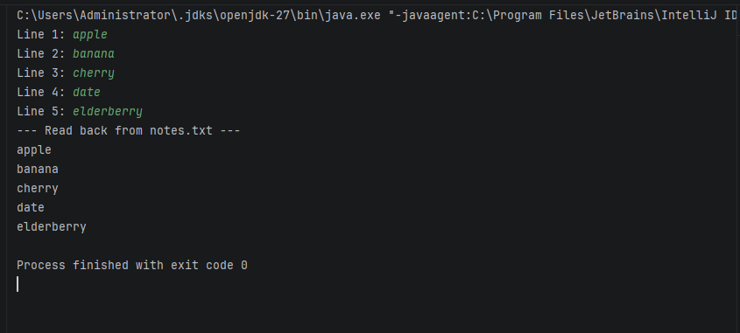

Question2
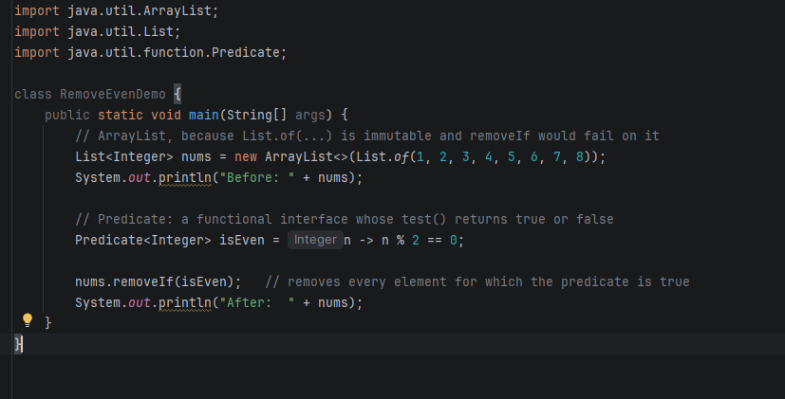
Output
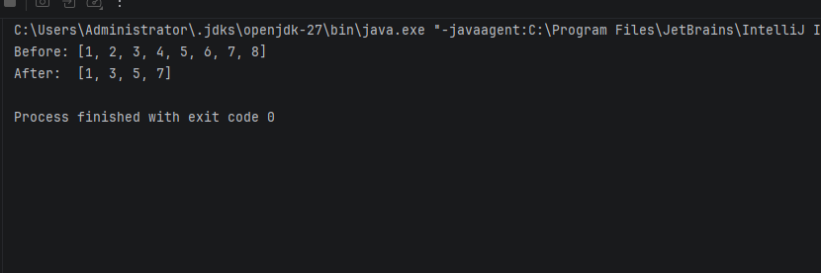

Question3
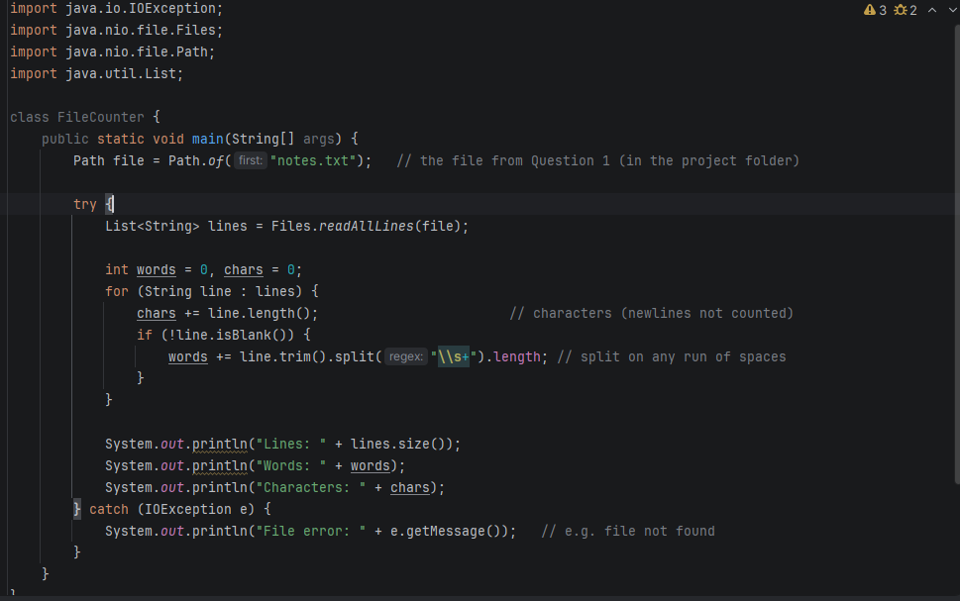

Output
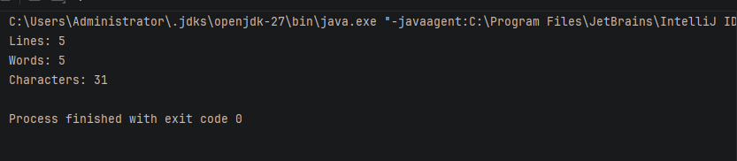
Question4
import java.util.List;
import java.util.stream.Collectors;
// record: immutable data carrier. Named StudentRecord to avoid clashing with your other Student classes.
record StudentRecord(String name, double marks) { }
class StreamDemo {
public static void main(String[] args) {
List<StudentRecord> students = List.of(
new StudentRecord("Asha", 80),
new StudentRecord("Rudo", 85),
new StudentRecord("Faith", 60),
new StudentRecord("Brian", 90),
new StudentRecord("Chipo", 55)
);
// Class average: stream the marks and take the average
double average = students.stream()
.mapToDouble(StudentRecord::marks)
.average()
.orElse(0);
System.out.println("Class average: " + average);
// Names above the average, sorted alphabetically
List<String> aboveAverage = students.stream()
.filter(s -> s.marks() > average) // keep students above the average
.map(StudentRecord::name) // take just the names
.sorted() // alphabetical order
.collect(Collectors.toList()); // gather the result into a list
System.out.println("Above average: " + aboveAverage);
}
}

Output
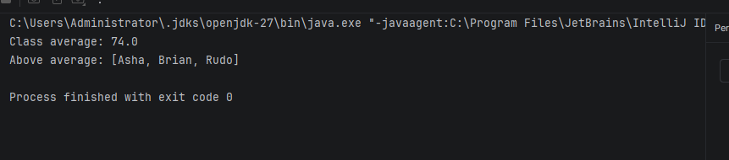
Question5
import java.io.IOException;
import java.nio.file.Files;
import java.nio.file.Path;
import java.util.List;
import java.util.Map;
import java.util.TreeMap;
import java.util.stream.Collectors;
record Learner(String name, double marks) {
// Grade band worked out from the marks, not stored
String band() { return marks >= 80 ? "A" : marks >= 60 ? "B" : "C"; }
}
class LearnerReport {
public static void main(String[] args) {
try {
// 1. Load learners from learners.csv (each line looks like: Asha,85)
List<Learner> learners = Files.readAllLines(Path.of("learners.csv")).stream()
.map(line -> line.split(","))
.map(p -> new Learner(p[0].trim(), Double.parseDouble(p[1].trim())))
.collect(Collectors.toList());
// 2. Group by grade band; TreeMap keeps the bands in order A, B, C
Map<String, List<Learner>> byBand = learners.stream()
.collect(Collectors.groupingBy(Learner::band, TreeMap::new, Collectors.toList()));
// 3. Write one report file per band
for (Map.Entry<String, List<Learner>> e : byBand.entrySet()) {
List<String> lines = e.getValue().stream()
.map(l -> l.name() + "," + l.marks())
.collect(Collectors.toList());
Path report = Path.of("band_" + e.getKey() + ".txt");
Files.write(report, lines);
System.out.println("Band " + e.getKey() + ": " + lines.size() + " -> " + report);
}
} catch (IOException e) {
System.out.println("File error: " + e.getMessage()); // e.g. learners.csv not found
}
}
}

Ada,78
Ben,65
Cara,45
Dan,82
Eve,50
Tom,30
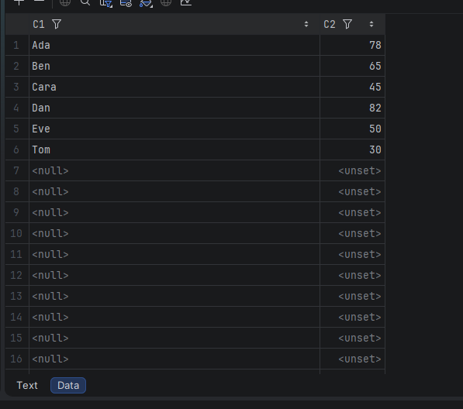
Output
